Beta Document

How too Install firmware to esp32 for Drybox

Install Arduino IDE V1.8 , NOT VERSION 2! <https://www.arduino.cc/en/software>

Once installed goto:-

File >

Preferences

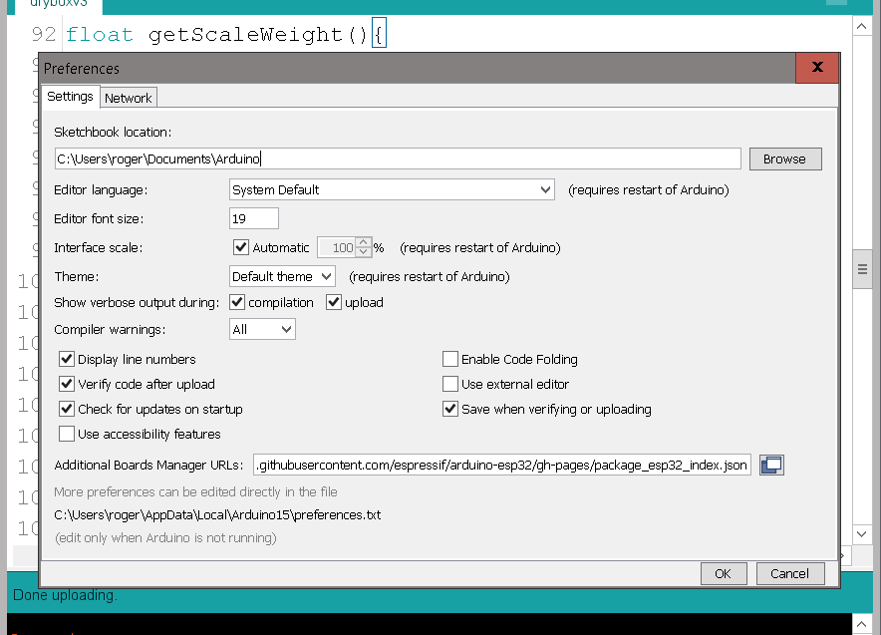

Add the line below into the “Additional Boards Manger URLs:”

<https://raw.githubusercontent.com/espressif/arduino-esp32/gh-pages/package_esp32_index.json>

Restart Arduino IDE

Once restarted goto:-

Tools  
 Board

ESP32 Arduino

*And select* ESP32 Dev Module

Next install Spifffs data upload add in

Instructions

<https://randomnerdtutorials.com/install-esp32-filesystem-uploader-arduino-ide/>